A000-Afr-Egy-Ushabti-Green Faience-Black Ink-New Kingdom-1850-1782 BCE

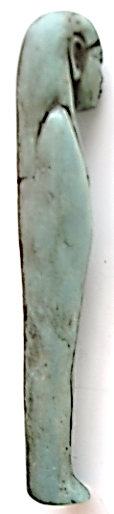 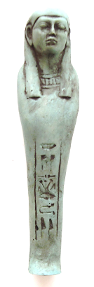 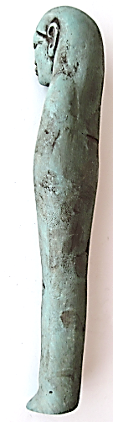 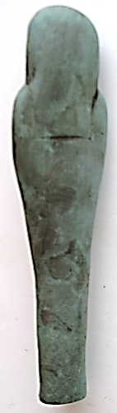

**Case no.: 2**

**Accession Number:**

**Formal Label:** Ushabti-Green Faience-Black Ink-New Kingdom-1850-1782 BCE

**Display Description:**

**Mummiform funerary statuette with plain tripartite wig with long lappets. Face well rendered with traces of black ink applied to hieroglyphics on front.**

**LC Classification: NB 75**

**Date or Time Horizon:** New Kingdom-1850-1782 BCE

**Geographical Area:** Abydos

**Map:**

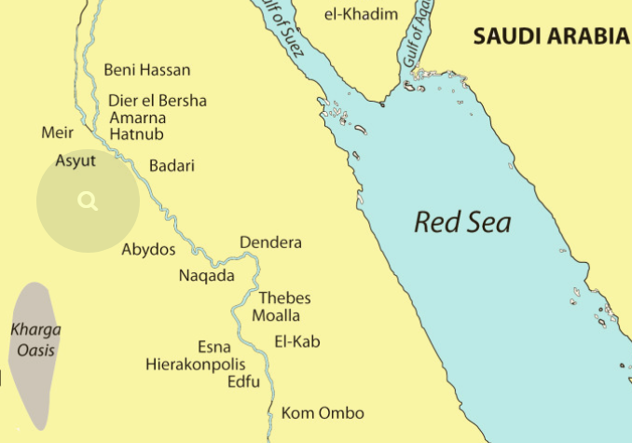

Location of Abydos after http://mepexonline.com/wp-content/uploads/2016/05/EgyptSitesMap-Coloured.jpg

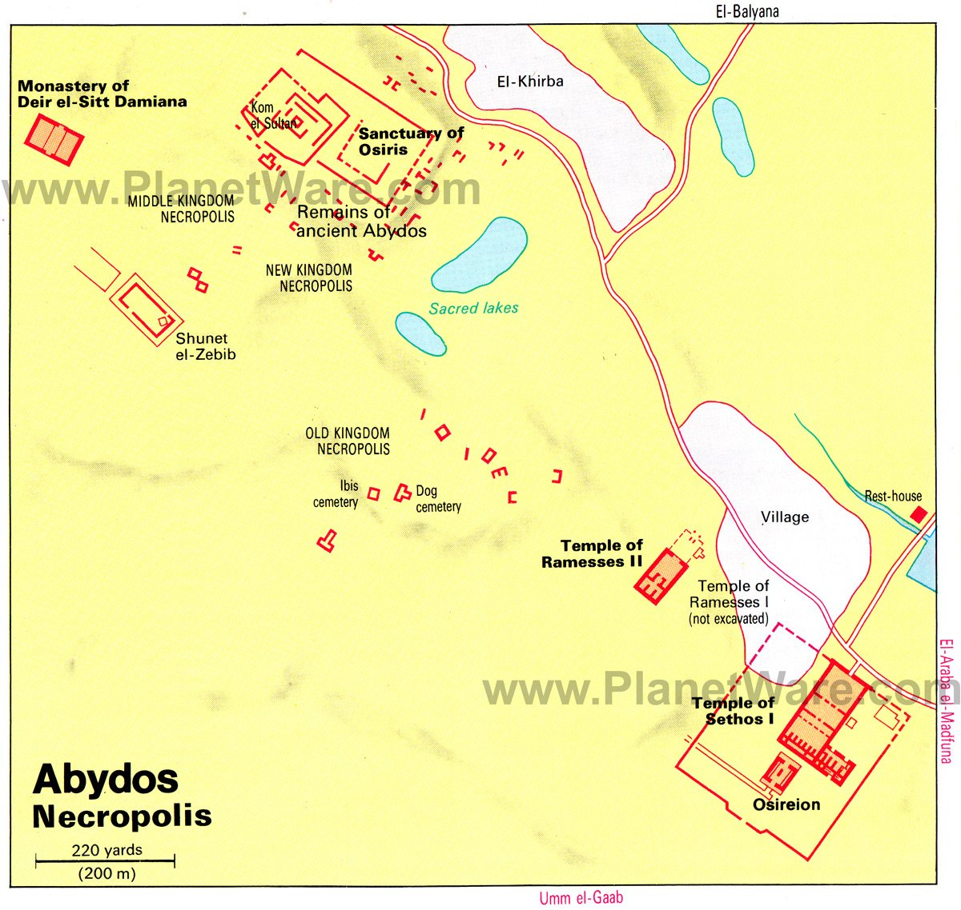

**http://www.planetware.com/i/map/EGY/abydos-necropolis-map.jpg**

**GPS coordinates: Latitude:** 26° 11' 3.30" N, **Longitude:** 31° 55' 4.76" E

**Cultural Affiliation:** New Kingdom-1850-1782 BCE

**Media:** Green faience, black ink

**Dimensions:** 10.58 in; 416.7 mm

**Weight: 8.5 oz, 241 gm**

**Condition: original**

**Provenance:**

**Discussion:**

**References:**

James, Glenn. 2007. *Shabtis, a private View*. Paris: Cybele.